A data model diagram for the given scenario is shown below.

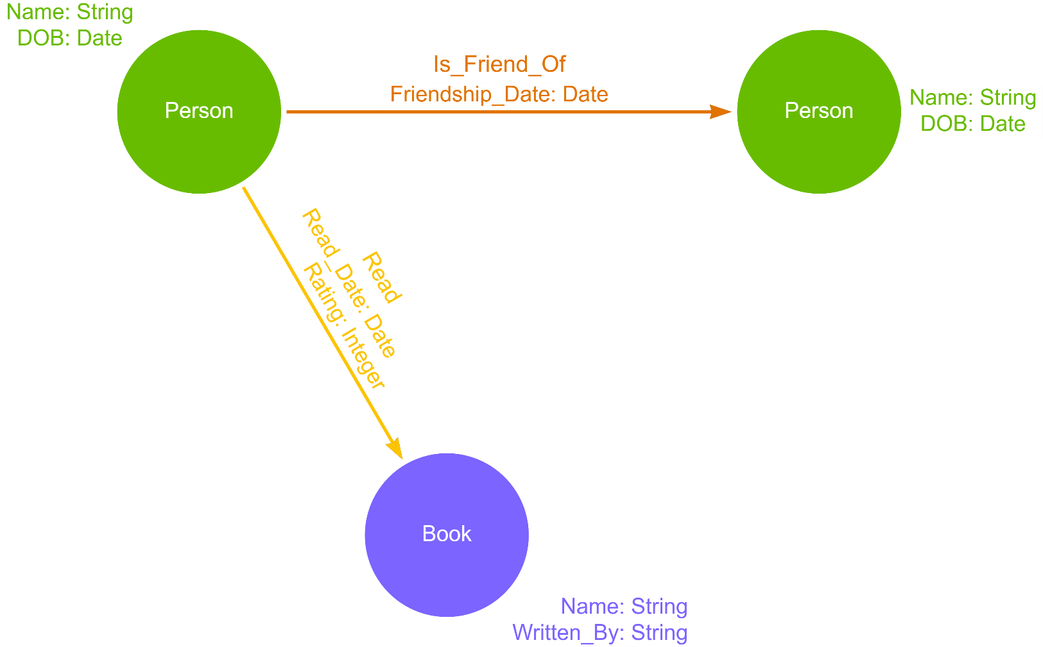

Figure 1: Data Model Diagram

## **Q.No.1**

Based on the above data model, nodes and relationships are created.

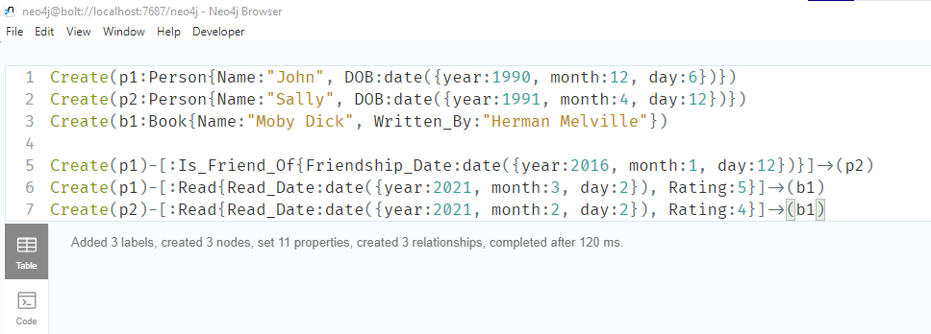

Figure 2: Creation of nodes and relationship

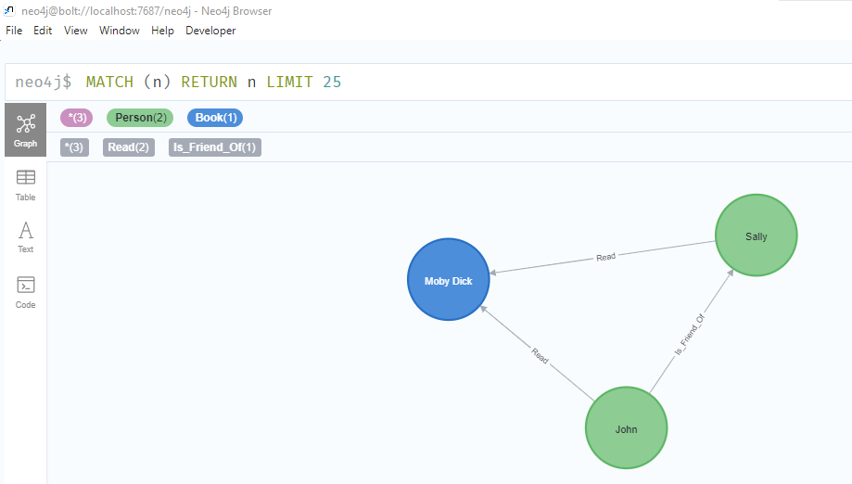

Figure 3: Created Nodes and Relationships

## **Q.No.2**

The age of Sally is given below.

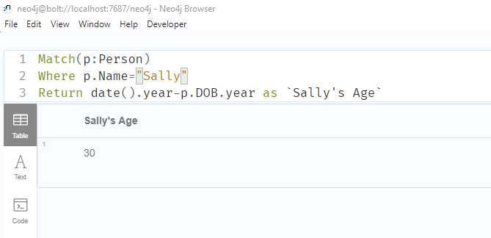

Figure 4: Sally's age

## **Q.No.3**

Sally read the book first which is shown below.

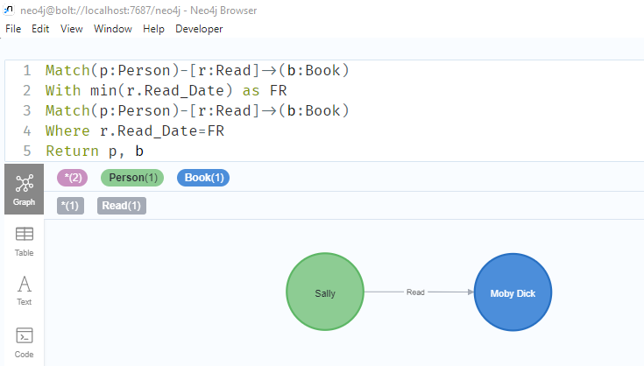

Figure 5: Who read the book first, Sally or John?

## **Q.No.4**

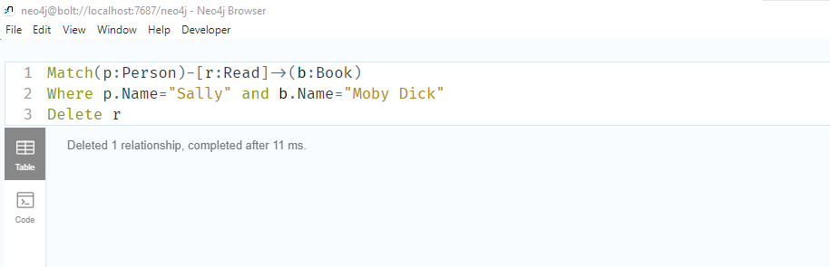

Figure 6: Removing relationship between Sally and the book

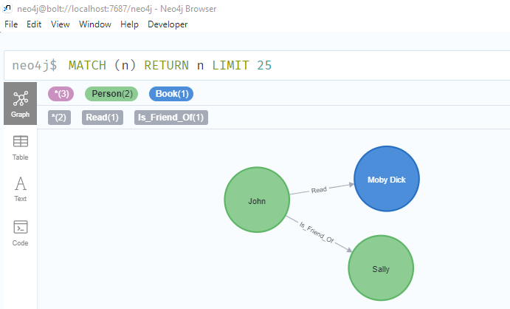

Figure 7: Graph after removing Sally's and the book's relationship

## **Q.No.5**

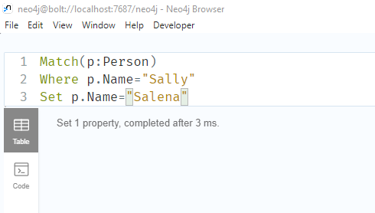

Figure 8: Updating Sally's name to Salena

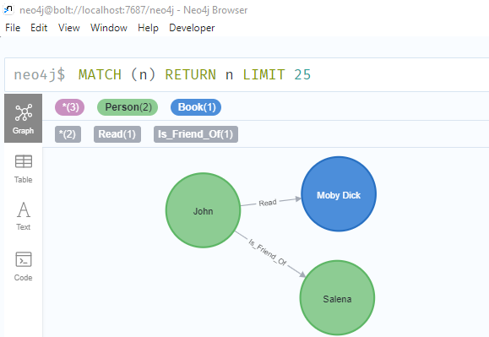

Figure 9: Graph after updating Sally's name

## **Q.No.6**

All the nodes and relationships except John are deleted which is shown below.

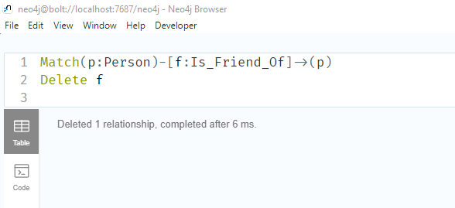

Figure 10: Deleting Friendship relationship between persons

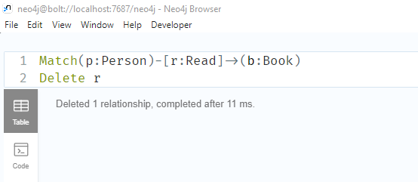

Figure 11: Deleting relationship between person and book

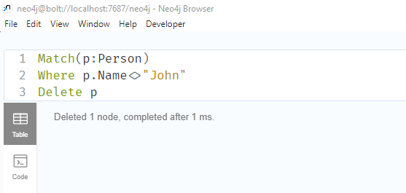

Figure 12: Deleting Person nodes except John

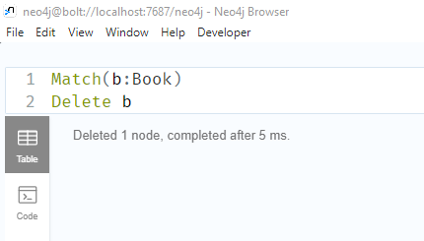

Figure 13: Deleting all book nodes

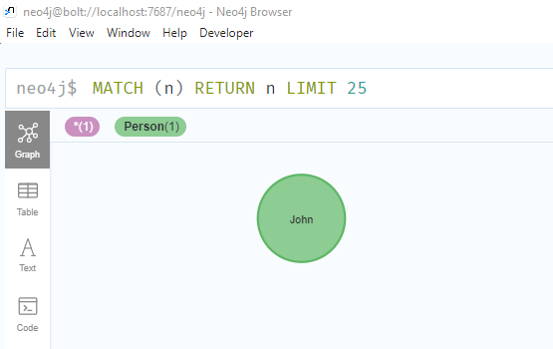

Figure 14:Graph after deleting all the nodes and relationships except John